# Recognizing substances

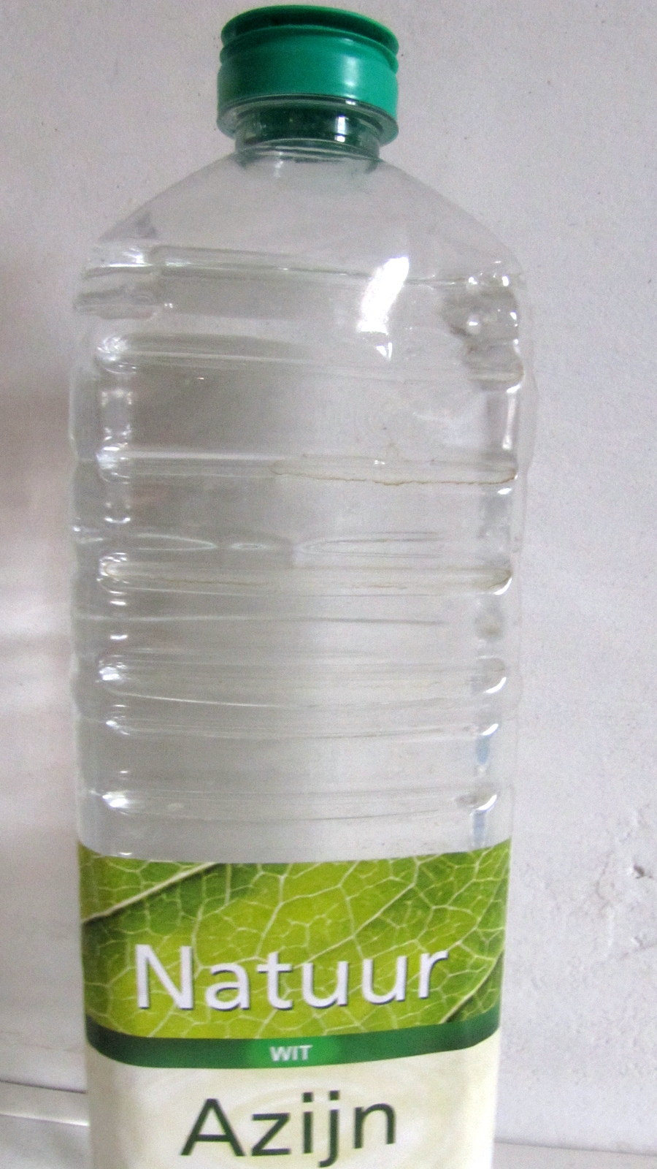

**Why do you want to be able to recognize substances?**

Your mom needs vinegar for the lettuce. And you have to go quickly to get a bottle of vinegar. You return home and your mom asks, "Where did you get that bottle?"

"Why?" ...... you ask.

"Well the cap has been off, take a look" .... your mother says.

You don't want to taste it, but you still want to know if there's water or vinegar or something else in it.

How could you do that?

## 1 Recognizing substances, by what? (Organizing)

**Beforehand**

Substances can be toxic. So it's important to be able to recognize substances. As long as they are in a jar or a canister with a label on it, it will work. But how do you know which substance is in it if there is no label on it?

1. Name a poisonous gas produced by incomplete combustion: . . . . . . . . . . . . . . . . .

2. Name a toxic liquid that could be in the kitchen cupboard at home . . . . . . . . . . . . . . . . .

3. Look up a toxic solid on the internet: . . . . . . . . . . . . . . . . . .

4. Explain why you should never taste a substance at school:

5. Think of two things you could do to find out what substance is in the vinegar bottle.

. . . . . . . . . . . . . . . .

**Necessary**

• 10 jars with different substances in them.

**Do**

6. If you look at the substances in the jars, you can find out a little more. For example, sugar and flour are both white, but if you look closely you can see differences. Fill in the table

|  |  |  |  |  |  |
| --- | --- | --- | --- | --- | --- |
| nr | Color | Smell | Solid/liquid/gas | Details | Name |
| 1 |  |  |  |  |  |
| 2 |  |  |  |  |  |
| 3 |  |  |  |  |  |
| 4 |  |  |  |  |  |
| 5 |  |  |  |  |  |
| 6 |  |  |  |  |  |
| 7 |  |  |  |  |  |
| 8 |  |  |  |  |  |
| 9 |  |  |  |  |  |
| 10 |  |  |  |  |  |

## 2. Can you recognize substances by putting them in water? (investigation)

**Prior to**

First a few questions about the substances in the jars in test 1. There were two substances that were both white and colourless and had no clear crystals. We will now look for a property in which the two substances differ.

7. Icing sugar and flour are very similar. **Name 3 substance-properties that are the same for icing sugar and flour:**

1. . . . . . . . . . . . . . . . . . . . .

2. . . . . . . . . . . . . . . . . . . . .

3. . . . . . . . . . . . . . . . . . . . .

8. There are several ways to discover which bottle contains flour and which contains powdered sugar. **Name three:**

1. . . . . . . . . . . . . . . . . . . . .

2. . . . . . . . . . . . . . . . . . . . .

3. . . . . . . . . . . . . . . . . . . . .

**Necessary**

• Two test tubes

• Water

• Icing sugar and flour

**Doing**

a. Come up with a study that will show you which substance is sugar and which is flour.

9. Write a short report of 20 words below:

10. Which of the two substances forms a suspension with water. (A suspension is a liquid in which very small solid particles are still floating) Explain:

11. In a solution, the liquid is clear and you can no longer see loose particles that sink to the bottom. So which of the two substances forms a solution?

. . . . . . . . . . . . . . . .

12. Which property, which is different for flour and sugar, did you use in this experiment:

. . . . . . . . . . . . . . . .

13. Suppose you receive 2 cups. Salt is dissolved in one cup and sugar is dissolved in the other. You are not allowed to taste. Yet there is another property different from sugar and salt. Now think of a way to distinguish between a sugar and a salt solution. (If you don’t know you will discover it doing question 20)

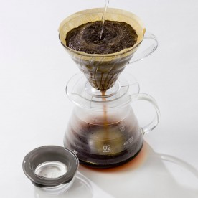14. Here you can see how coffee is made. The hot water removes the coffee aromas from the coffee beans while other substances remain in the beans. The coffee flows through the filter, the ground beans remain behind. This is because there is a difference in the properties of coffee particles and the particles in ground coffee beans. This property is:

. . . . . . . . . . . . . . . .

**Conclusion**

15. You can distinguish substances from each other if you can find a property that

. . . . . . . . . . . . . . . .

16. Explain whether a sugar solution is a pure substance (one type of particles) or not:

## 3 How do you recognize metals and non-metals? (Investigation)

**Prior to**

The metals are a group of solids that are widely used. We will investigate this group of substances in more detail. You are given a series of metal objects or look for them in your environment and you have to try to find out for yourself which metal it is.

**Necessary**

• Magnet

• LED + resistor

• Corded power supply

• Piece of sandpaper

**Doing**

17. Complete the table.   
Tip: If necessary, sand the surface with sandpaper if you are going to investigate whether the substance is conductive. There should be no paint residue or rust layer on it.

|  |  |  |  |  |  |  |
| --- | --- | --- | --- | --- | --- | --- |
| nr | Color | Magnetic  yes/no | Conduct the current  yes/no | Flexibility  easy/difficult | Application | Name |
| 1 |  |  |  |  |  |  |
| 2 |  |  |  |  |  |  |
| 3 |  |  |  |  |  |  |
| 4 |  |  |  |  |  |  |
| 5 |  |  |  |  |  |  |
| 6 |  |  |  |  |  |  |
|  |  |  |  |  |  |  |
|  |  |  |  |  |  |  |

18. Fill in:

All metals…………………………………………..electric current. (name a property they all have)

Some metals are ………………………………………….. others are not.

19. I now know 7 properties of substances, namely:

● .........................

● .........................

● .........................

● .........................

● .........................

● .........................

Now carry out the research referred to in question 13 and investigate which solution conducts better: saline solution or a sugar solution. You can use the same setup as in act 3, but put a (bent) paperclip in the other crocodile's mouth.

* First look at how tap water conducts,
* then pure demineralised water
* then demineralised water with sugar
* and finally demineralized water with salt.

20. **Draw a conclusion from your research:**

## 4 Which has the greatest density: Sugar or rubber? (Relating context en concept)

**Before hand**

Substances are not all equally "heavy". But how can you honestly compare how "heavy" a fabric is? How could you determine the density of sugar or the density of rubber?

21. Which is heavier: One kilogram of lead or one kilogram of chicken feathers? Explain:

In short, you can make any substance as heavy as you want as long as you take a lot of volume from that substance. In the module "Balance" the concept “density” was already been introduced. To determine the density, we not only look at the mass, but also at the volume.

**Determine mass**

We will first determine the mass of a number of substances. In the module on balance you learned how to determine the mass with the balance. Read this again if you don't remember exactly. Or ask your teacher.

**Necessary**

|  |  |
| --- | --- |
| Materials | Substance |
| * 3 intake cups (2 in the balance and 1 loose) * balance * water * 10 mL syringe with graduation | * sugar cube * rubber stopper |

**Doing**

22. Determine the mass of 2 substances with the balance: **Measure:**

the mass of the rubber stopper = . . . . . . . . . . . . . . . . g

the mass of a cube of sugar =. . . . . . . . . . . . . . . . g

. . . . . . . . . . . . . . . . has the largest mass

23. Measure the volume of the rubber stopper by immersing it in a measuring cup and determine the increase in volume as accurately as possible.

Volume after . . . . . . . . . . . . . . . . mL (=cm3)

Volume for . . . . . . . . . . . . . . . . mL (=cm3)

**Volume rubber . . . . . . . . . . . . . . . . mL (=cm3)**

24. Calculate the volume of the sugar cube with the formula Volume = length x width x height.

Measurements (With a drafting triangle)

length = . . . . . . . . . . . . . . . . cm

width = . . . . . . . . . . . . . . . . cm

height = . . . . . . . . . . . . . . . . cm

Calculation:

**Volume: = . . . . . . . . . . . . . . . . cm3**

25. You can now calculate how much the volume of 1 cm3 of each substance weighs. Perform this calculation:

**The mass of 1 cm3 of a substance is called its density.**

**Calculate the density of rubber = . . . . . . . . . . . . . . . .**

**Calculate the density of sugar = . . . . . . . . . . . . . . . .**

**Rubber/sugar** has the largest density (Circle the correct answer)

26. Circle: Which of the three is a substance property: Mass, Density, Volume? And explain why:

Separate substances

## 5 How do you clean water? (Investigation)

**Prior to**

You have learned a lot about the properties of substances. If substances have different properties, you can use this to separate them. It is sometimes very important that you can properly separate substances. Just think of detoxification or waste separation.

In this test you are given a mixture of: Sandy soil and water and you are also given all the necessary materials to separate the substances in the mixture. You have to figure out how to do that yourself.

**Materials:**

• Large test tube (2x)

• Magnet

• Filter paper

• Intake cup with mixture

• Water

**Doing:**

1. Pour the mixture into a test tube and wait for a while.

27. **Write down** your observations:

Here you see a photo of a piece of rock. This rock was formed because pebbles, sand and mud sank down in water and were then compressed under high pressure.

28. What **similarities do you see with** the layers in the rock and the layers at the bottom of your test tube?

In assignment 27 the sand and dust that has fallen down is called sediment. Not everything has gone down. The sand in particular has disappeared from the water. So we separated the sand from the mud water. We call this process sedimentation.

29. The **SMALLEST/LARGEST** particles are still in the water.

Now think about how you could further purify the water.

TIP: fold a filter as shown below:

o Fold the filter in half twice

o And fold 1 piece to the left and 3 bits to the right.

o You can now use the filter (in the funnel) place on the test tube

**Make a work plan**

(Think about the order in which you will do things.)

i. ………………

ii. ………………

iii. ……………….

b) Once your work plan is approved, get some of the mixture and you can start.

30. Describe the test results:

**Explanation**

Mudwater is a mixture of water and soil particles. The soil particles float in the water. Such a mixture of a solid in a solution is called a **suspension**. If you wait long enough, these particles will largely sink to the bottom and the water will become increasingly clear. You can speed up this process by **centrifuging**. In fact, you increase the force of gravity that causes the particles to sink downwards.

The water particles are so small that they can easily pass through the filter, the soil particles are larger and cannot pass through the filter. (Provided the filter is fine enough). The substance that remains in the filter is always called the residue and the liquid that passes through it the filtrate.

## 6 How do you separate mixtures? (relating contexts en concepts)

**Prior to**

Substances are often mixed together. We have seen that mud water is a mixture of water and soil.

31. Circle the correct answer:

In the case of mud water we had a mixture of: **TWO LIQUIDS / ONE LIQUID AND A SOLID / TWO SOLIDS.**

Now we are going to separate a mixture of iron and sand.

32. Write down how you could do that:

**Necessary**

• Sand-iron mixture

• Magnet (in a piece of paper)

• Test tube

• Rubber stopper

**Doing**

a) Place 2 cm of the mixture in a test tube so that you can clearly observe the mixture.

b) Make sure that no iron gets stuck to the magnet by keeping the magnet outside the test tube.

c) Place the rubber stopper on the test tube and hold the magnet on the outside against the tube and shake the tube back and forth. After some time, hold the tube upside down over a beaker.

33. **Explain how well you were able to separate sand and iron**.

We have +/- . . . . . . . . . . . . . . . . % sand removed and . . . . . . . . . . . . . . . . % has remained in it.

Think about how you could improve the separating process:

## 7 Separating salt and sand. (Higher order assignment)

**Prior to**

Where do our cars come from? And the computers and cell phones? What are they made of and how do you get all those substances? But also: “Where do you put them when you don’t need them anymore?”

Many of these substances come from the soil. The soil contains many different types of substances. Mines in particular contain large (and smaller) quantities of all kinds of substances. Such as copper, iron, silver etc.

To get the substances you want, you often have to do a lot of purification processes. That's what we're going to talk about in this chapter.

Our table salt also comes from the ground. In the first test we will look at how you can separate soil (sand) and salt. Salt is an important substance. It is used in small amounts in many of our foods. But as mentioned, it usually occurs in nature mixed with other substances. To separate these two substances you have to make good use of the differences in properties of sand and salt.

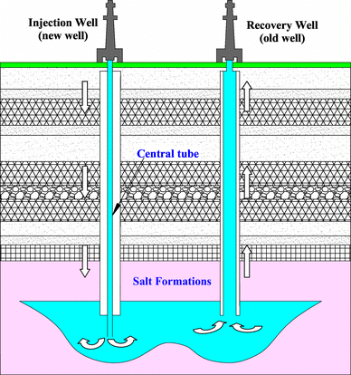**Necessary**

• test tube

•lid

• sand - salt mixture

•candle

• spoon (metal)

• water

• matches

• Filter paper

**Doing**

a) In the picture above you see a schematic representation of salt extraction from a salt-containing layer. It's about a kilometer underground.

34. Study the picture and think of a way to separate a sand-salt mixture of about 2 cm contained in a test tube.

1. You are now going to learn about dissolution, filtration and evaporation.
2. Use a metal spoon for the evaporation. And only fill it halfway with salt water before heating it over the candle.

35. Explain how you did it:

36. When making coffee you use **DISSOLUTION/EVAPORATION** and **FILTRATION/SEDIMENTATION**

37. Suppose: You mixed salt and pepper together. It is possible to separate salt and pepper using electrostatic attraction. Explain how? (use items from the E2Lab box):

May be you know another way to separate salt and pepper . . . . . . . . . . . . . . . . .

d) If there is still time, you can try it. You can charge a straw electrically if you rub it against your clothes or through your hair.

## 8 Distillation (Investigation)

**Prior to**

In the previous experiments, solids were always dissolved in a liquid. We are now going to separate a mixture of two liquids.

**Necessary**

See picture at the right

**Doing**

a) It’s important that you look at the picture carefully. Keep the use of matches to a minimum. Make sure the clip does not burn black!

b) Build the setup shown in the picture above and add no more than 2 cm of wine to the tube.

c) Heat the wine exactly where indicated in the picture. Do that slowly!!

38. If you only heated the bottom, the wine could. . . . . . . . . . . . . . . . . . .

d) Pay close attention to what is happening in the tube. Do not let the test tube turn black.

e) As soon as a little liquid comes out of the tube. Can you test it for flammability with a match. Test (especially) the first drop that comes out of the tube.

39. Write down your observations from the moment you continue to heat and the first liquid flows down the tube. Occasionally test for flammability.

40. Explain what the substance is this that comes out of the tube:

41. This separation method is most similar to (Choose from one of the 3) SEDIMENTATION/EVAPORATION/FILTRATION. There is also a difference. Name the difference:

42. The substance that first came out of the tube was WATER/ALCOHOL and the substance that came out after some time was **WATER/ALCOHOL/MIXTURE OF BOTH**

43. Name two properties that water and alcohol have in common:

. . . . . . . . . . . . . . . . . . . .

. . . . . . . . . . . . . . . . . . . .

44. Name one property of water and alcohol that is different:

. . . . . . . . . . . . . . . . . . . .

45. Wine contains at least 3 different substances

............................, .................... ......., and ............................

46. ​​I know this because

## 9 Extracting colouring from red wine (relating contexts en concepts)

**Prior to**

If you know more about different substances and know more and more methods to purify substances, you can make increasingly purer substances.

We show that in this test. We are going to remove the red dye from red wine.

47. Explain if you can remove the red food coloring by just filtering the red wine?

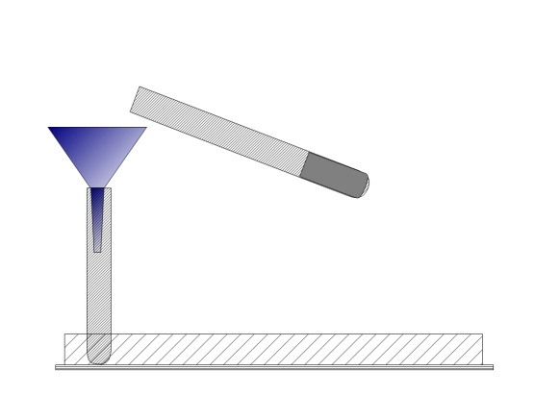**Necessary**

• See picture at the right

**Doing**

a) Place the Norit tablet on a piece of paper and grind it finely. You can do this by pressing firmly on the debris with the bottom of a test tube.

b) Place 5 cm of wine in the large test tube

c) Fold the paper with the Norit-powder forming a V-shape to make it easier to put the Norit in the tube.

d) Put your thumb on the test tube and shake the wine with the and Norit-powder well for some time.

e) Fold the filter (see assignation 29) and pour about half of wine + norit through the filter.

48. Write down what you observe:

49. The liquid that has passed through the filter (=filtrate) is:

. . . . . . . . . . . . . . . .

50. The “sludge” left behind in the filter (= residue) consists of:

. . . . . . . . . . . . . . . .

51. Now try to explain why there is no red coloring in the wine anymore.   
Explain who you think makes the best statement: Black / Suitcaseman / Bookworm

(circle) because:

I take Norit with me when I travel. Norit can absorb germs so I think Norit has made the dye disappear

C:\Documents and Settings\A. Moerdijk\Local Settings\Temporary Internet Files\Content.IE5\998VYQ8A\MC900437571[1].wmfC:\Documents and Settings\A. Moerdijk\Local Settings\Temporary Internet Files\Content.IE5\RQWOE7FI\MC900440424[1].wmfC:\Documents and Settings\A. Moerdijk\Local Settings\Temporary Internet Files\Content.IE5\998VYQ8A\MC900323381[1].wmf

Norit is blacker than the red of the wine, so the black has won and the red is gone

The red dye is stuck to the Norit and because the Norit could not pass through the filter, the dye also remained stuck there.